**Q1) Types of banks?**

Ans- -There are two main categories of Commercial Bank in India namely:-

1. Scheduled Commercial Bank

2. Scheduled Co-operative Bank

Scheduled Commercial Banks are again divided into five types and the Scheduled

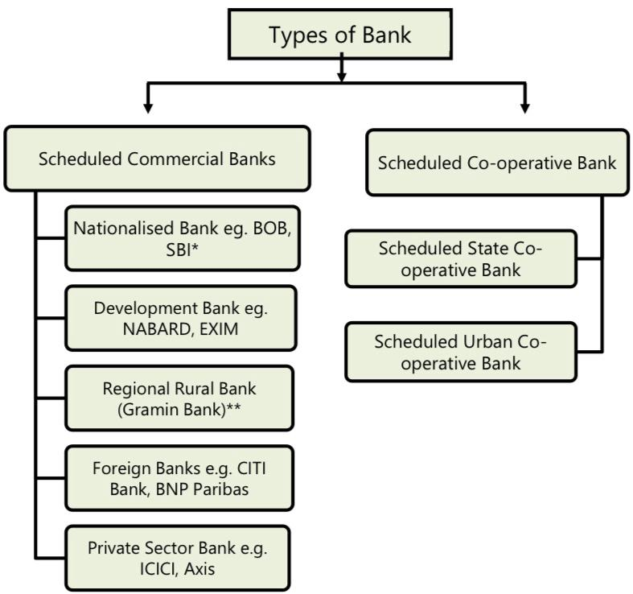

Scheduled Banks in India constitute those banks which have been included in the Second Schedule of Reserve Bank of India(RBI) Act, 1934. After May 1997 there are no non-scheduled commercial banks existing in India. However, there are small to tiny non-scheduled Urban Co-operative Banks also known as Nidhi ond Schedule ots of the country.

The banks included in this schedule list should fulfil following two conditions:

1. The paid up capital and reserves in aggregate should not be less than § 5 lakhs.

2. Any activity of the bank will not adversely affect the interests of depositors.

The Reserve Bank includes a bank in this schedule if it fulfils certain other conditions too. The RBI as the Central Bank is the 'Bank of Last Resort' i.e. when other commercial banks are in trouble RBI helps them out.

**Q) Explain the following?**

**1) Reserve funds-** Every banking company incorporated in India is required to create a Reserve Fund and to transfer at least 25% of its profit to the reserve fund as per RBI notification (as against 20% prescribed in Banking Regulation Act). The profit of the year as per the profit and loss account prepared under Section 29 is to be taken as base for the purpose of such transfer and transfer to reserve fund should be made before declaration of any dividend.

If any banking company makes any appropriation from the reserve fund or share premium account, it has to report to the Reserve Bank of India the reasons for such appropriation within 21 days.

**2) Non Banking Assets-** Non-banking assets refer to financial assets that are not held or managed by traditional banks. These assets are typically held by entities other than banks, such as non-banking financial institutions (NBFIs), investment firms, insurance companies, pension funds, and individuals.

Here are some examples of non-banking assets:

Stocks and Equities: Ownership shares in publicly traded companies are considered non-banking assets. Investors can purchase stocks through stock exchanges or investment firms to gain ownership and potential returns based on the performance of the company.

Bonds: Bonds are debt instruments issued by governments, municipalities, corporations, and other entities to raise capital. They represent loans made by investors to the issuer in exchange for regular interest payments and the repayment of the principal amount at maturity.

Mutual Funds: Mutual funds pool money from multiple investors to invest in a diversified portfolio of stocks, bonds, or other assets. They are managed by professional fund managers and offer investors the opportunity to access a diversified investment portfolio without having to directly purchase and manage individual securities.

Exchange-Traded Funds (ETFs): ETFs are investment funds that are traded on stock exchanges, similar to stocks. They can hold a variety of assets, such as stocks, bonds, commodities, or a combination thereof. ETFs provide investors with the ability to gain exposure to specific sectors, markets, or investment strategies.

Real Estate: Non-banking assets can include physical properties such as residential, commercial, or industrial real estate. Real estate investments can generate rental income and potential appreciation in value over time.

It's important to note that investing in non-banking assets typically involves varying degrees of risk, and investors should carefully consider their investment goals, risk tolerance, and conduct thorough research before making investment decisions. Additionally, regulations governing non-banking assets may vary across jurisdictions, so it's essential to be aware of the applicable rules and regulations in a particular country or region.

**3) Loss Assets-** Loss of assets refers to the situation where a person, organization, or entity experiences a reduction or disappearance of their assets, resulting in a financial or economic setback. It can occur due to various reasons, including theft, damage, destruction, depreciation, mismanagement, fraud, or economic factors.

Here are some common scenarios that can lead to a loss of assets:

Theft and Fraud: Assets can be lost through theft or fraudulent activities committed by internal or external parties. This may include theft of physical assets like cash, inventory, or equipment, or financial fraud such as embezzlement, identity theft, or unauthorized access to accounts.

Depreciation: Over time, certain assets may lose value due to wear and tear, obsolescence, or changes in market conditions. Depreciation is an accounting concept that reflects the decrease in the value of assets over their useful life. The decline in asset value represents a loss, although it may not be an immediate or tangible loss in the same sense as theft or damage.

Financial Market Fluctuations: Investments in stocks, bonds, commodities, or other financial instruments are subject to market fluctuations. Changes in market conditions, economic downturns, or unfavorable events can lead to a decline in the value of investment portfolios, resulting in a loss of assets for investors.

**Q3) What is meant by statutory Reserve?**

Ans- Statutory reserve refers to a specific type of financial reserve that certain entities, such as banks and insurance companies, are required to maintain by law or regulation. It is a portion of their profits that must be set aside and held in reserve to ensure the stability and solvency of the institution.

Statutory reserves serve as a form of protection against potential losses or financial instability. They act as a buffer to cover unexpected events or financial difficulties that may arise in the future. These reserves are typically mandated by government or regulatory authorities to safeguard the interests of depositors, policyholders, and other stakeholders.

The specific rules and requirements regarding statutory reserves vary across jurisdictions and industries. Regulatory bodies often determine the formula or method for calculating the amount of statutory reserves, which can be based on factors like the entity's financial performance, risk exposure, or the volume of business conducted.

The purpose of statutory reserves is to ensure that regulated entities maintain a certain level of financial security, liquidity, and ability to meet their obligations. By holding these reserves, institutions are better equipped to handle adverse economic conditions, unexpected losses, or other challenges that may arise in their operations.

**O4) Claim for Loss of profit and loss of stock?**

Ans- Claim For loss of profit- When a fire occurs, apart from the direct loss on account of stock or other assets destroyed, there is also a consequential loss because, for some time, the business is disorganized or has to be discontinued, and during that period, the standing expenses of the business like rent, salaries etc. continue. Moreover, there is loss of profits which the business would have earned during the period. The Loss of Profit Policy normally covers the following items:

(1) Loss of net profit

(2) Any increased cost of working.

In every business, there is some standard by which its activity or progress can be accurately judged: it may be sales affected or the quantity of goods (or services) produced. To measure the loss suffered by a firm due to fire, it is necessary to set up some standard expressed in such units to represents the volume of work. There should be a direct relation between the amount of standard and the amount of profit raised.

Claim for loss of stock- Fire insurance being a contract of indemnity, a claim can be lodged only for the actual amount of the loss, not exceeding the insured value. In dealing with problems requiring determination of the claim the following point must be noted:

* Total Loss: If the goods are totally destroyed, the amount of claim is equal to the actual loss, provided the goods are fully insured. However, in case of under insurance (i.e. insurable value of stock insured is more than the sum insured), the amount of claim is restricted to the policy amount.
* Partial Loss: If the goods are partially destroyed, the amount of claim is equal to the actual loss provided the goods are fully insured. However, in case of under insurance, the amount of claim will depend upon the nature of insurance policy as follows:

Without Average clause: Claim is equal to the lower of actual loss or the sum insured.

With Average Clause: Amount of claim for loss of stock is proportionately reduced, considering the ratio of policy amount (i.e. insured amount) to the value of stock as on the date of fire (i.e. insurable amount) as shown below:

Amount of claim = Loss of stock × sum insured / Insurable amount (Total Cost)

One should note that the average clause applies only where the insured value is less than the total cost and not when goods are fully insured.

**Q5) Explain Average clause?**

Ans- Average Clause: Insurance policies provide that if the sum insured in respect of loss of profit is less than the sum produced by applying the rate of gross profit to the annual turnover (as adjusted by the trend of the business or variation in special circumstances affecting the business either before or after the damage or which would have affected the business had the damage not occurred), the amount payable by the insurer shall be proportionately reduced. This is nothing but application of the average clause.

The turnover of a business rarely remains constant and where there has been an upward or downward trend since the date of the last accounts and upto the date of the fire, the "standard turnover" should be appropriately adjusted, as per definition given above.

Similarly, where the earning capacity of the business has changed, the rate of gross profit may not represent a correct indication of the lots and mutually agreed rate may be used for the computation.

Students should carefully go through the working of the following illustration to understand the process of the computation of the claim made on a "Loss of Profit" policy.

**Q6) Significance of average clause in a fire insurance policy?**

Ans- The average clause in a fire insurance policy is a provision that determines how a claim settlement will be calculated if the insured property is underinsured at the time of the loss. It is designed to encourage policyholders to adequately insure their property and prevent them from undervaluing their assets to reduce insurance premiums.

Here's the significance of the average clause in a fire insurance policy:

Fair Distribution of Losses: The average clause helps ensure a fair distribution of losses between the insurer and the policyholder. It prevents overcompensation for partial losses when the property is insured for less than its actual value. Without the average clause, underinsured policyholders could receive a full claim payment, leaving insurers to bear a disproportionate share of the loss.

Calculation of Claim Settlement: When a loss occurs, the average clause is applied to determine the amount of the claim settlement. The settlement is calculated based on the ratio of the insured value to the actual value of the property. For example, if the insured property is valued at 80% of its actual value, the insurer will only pay 80% of the total loss.

Risk Management and Loss Prevention: The average clause serves as a risk management tool by encouraging policyholders to take appropriate measures to prevent losses and minimize damages. Insured individuals or businesses are more likely to implement safety measures, maintain fire protection systems, and follow best practices to reduce the risk of fires and associated losses.

**Q7) Difference between**

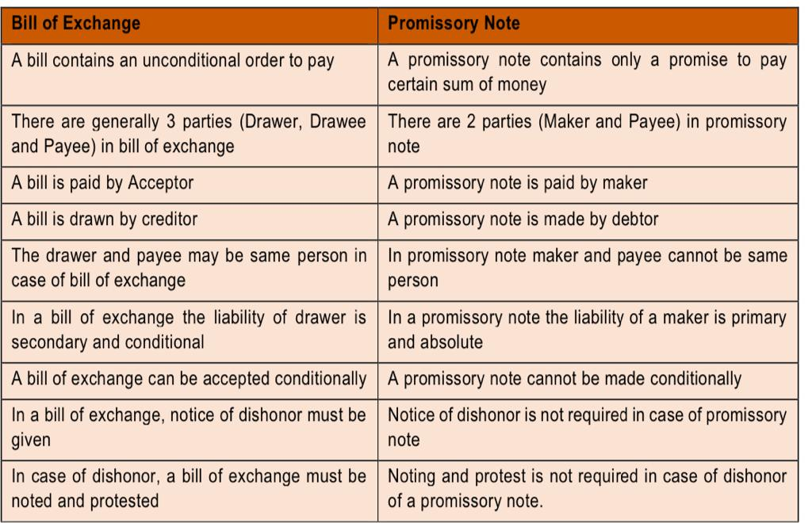

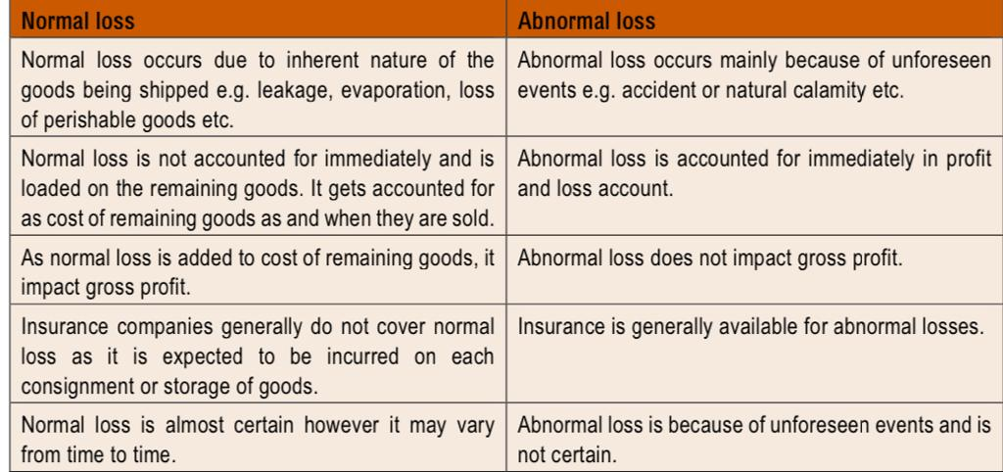

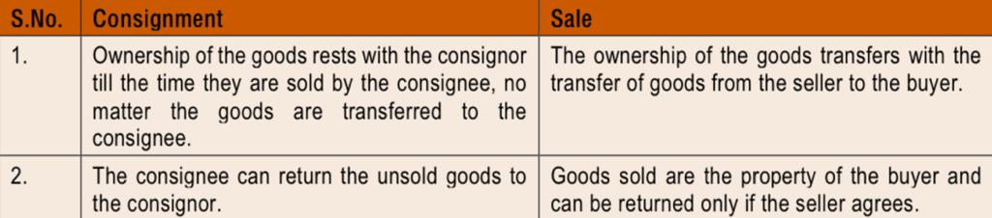

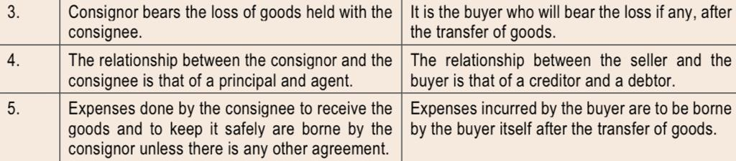

**Q8) Explain Accommodation bills?**

Ans- Bills of Exchange are usually drawn to facilitate trade transmission, that is, bills are meant to finance actual purchase and sale of goods. But the mechanism of bill can be utilised to raise finance also. Suppose Boss needs finance for three months. In that case he may persuade his friend Kapoor to accept his draft. The bill of exchange may then be taken by Boss to his bank and get it discounted there. Thus, Boss will be able to make use of funds.

When the three months period expires, Boss will send the requisite amount to Kapoor and Kapoor will meet the bill. Thus, Boss is able to raise money for his use. If both Boss and Kapoor need money, the same devise can be used. Either Boss accepts a bill of exchange or Kapoor does. In either case, the bill will be discounted with the bank and the proceeds divided between the two parties according to mutual agreement. The discounting charges must also be borne by the two parties in the same ratio in which the proceeds are divided. On the due date the acceptor will receive from the other party his share. The bill will then be met. When bills are used for such a purpose, they are known as accommodation bills.

However, it may so happen that the drawer is not able to remit the proceeds to drawee on the due date. In such a case, the drawee may draw a bill on the drawer, and get it discounted with the bank to honour the first bill. If the new drawer (drawee of the first bill) also remits some proceeds of the new bill to new drawee (drawer of the first bill), then the proportion of discount to be borne by the new drawee will be based upon the proceeds remitted as well as the benefit obtained by him on the first bill.

**Q9) Explain for bill for collection of a bill of exchange?**

Ans- When a person receives a bill of exchange, he may decide to retain the bill till the date of maturity. But in order to ensure safety, he may send it to bank with instructions that the bill should be retained till maturity and should be realised on that date. This does not mean discounting because the bank will not credit the client until the amount is actually realised. If the bill is sent to the bank with such instructions it is known as "Bill sent for collection".

It is better to make a record of this also in books by passing following entry:

Bills for Collection Account Dr.

To Bills Receivable Account

(When the amount is realised the entry will be)

Bank Account Dr.

To Bills for Collection Account

When the amount is not honoured, the entry will be

Party (from whom the bill was received)

To Bills for collections A/c

**Q10) Explain Del-credere commission?**

Ans Del-credere commission is a type of commission paid by a seller to a third-party agent or intermediary, known as a del-credere agent or commission agent. This commission is provided in exchange for assuming the risk of the buyer's default on payment for goods or services sold.

Here's an explanation of del-credere commission:

Risk Protection: When a seller enters into a sales transaction, there is a risk that the buyer may default on payment. The del-credere commission acts as a form of insurance for the seller against the risk of non-payment by the buyer. The commission agent, known as the del-credere agent, guarantees the payment to the seller, even if the buyer fails to make payment.

Higher Commission Rate: In return for assuming the risk and taking on the collection responsibilities, the del-credere agent typically charges a higher commission rate compared to a regular sales agent. The commission is often calculated as a percentage of the sales value or as an agreed-upon fixed fee.

Legal Relationship: The arrangement between the seller, the del-credere agent, and the buyer is typically governed by a del-credere agreement or contract. This agreement outlines the roles and responsibilities of each party, the commission rate, the credit terms, and the conditions under which the del-credere agent becomes liable for non-payment.

**Q11) Explain concept of joint venture?**Ans- A joint venture (JV) is a business arrangement in which two or more independent entities or companies come together to undertake a specific business project or pursue a common goal. In a joint venture, the participating entities pool their resources, expertise, and capital to share risks, responsibilities, and rewards associated with the venture.

Here's an explanation of the concept of a joint venture:

Shared Ownership and Control: In a joint venture, the participating entities typically have shared ownership and control over the venture. The ownership structure can vary depending on the agreement and the specific needs of the venture. The joint venture may be established as a separate legal entity, such as a partnership, corporation, or limited liability company (LLC), or it may be an unincorporated entity governed by a contractual agreement.

Shared Risks and Rewards: Joint ventures involve sharing risks and rewards between the participating entities. The entities contribute financial resources, assets, intellectual property, or other valuable contributions to the venture. In return, they share in the profits, losses, and liabilities generated by the joint venture in proportion to their ownership or as agreed upon in the joint venture agreement.

Autonomy and Decision-Making: Joint ventures allow the participating entities to retain their autonomy and separate legal identities while working together towards a common goal. Decision-making processes can vary depending on the structure and agreements of the joint venture. In some cases, decisions may require consensus or be based on proportional ownership interests, while in other cases, decision-making authority may be delegated to a management team or board of directors.

**Q12) Difference between**

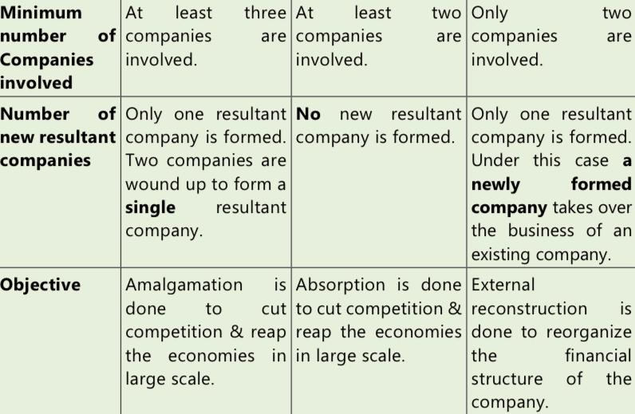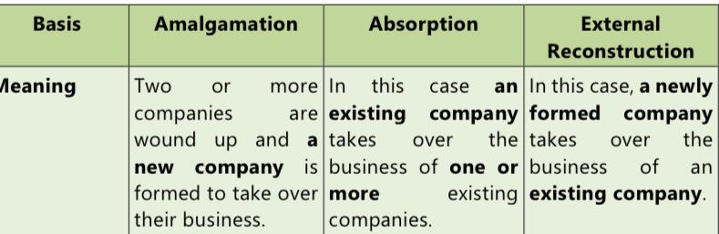

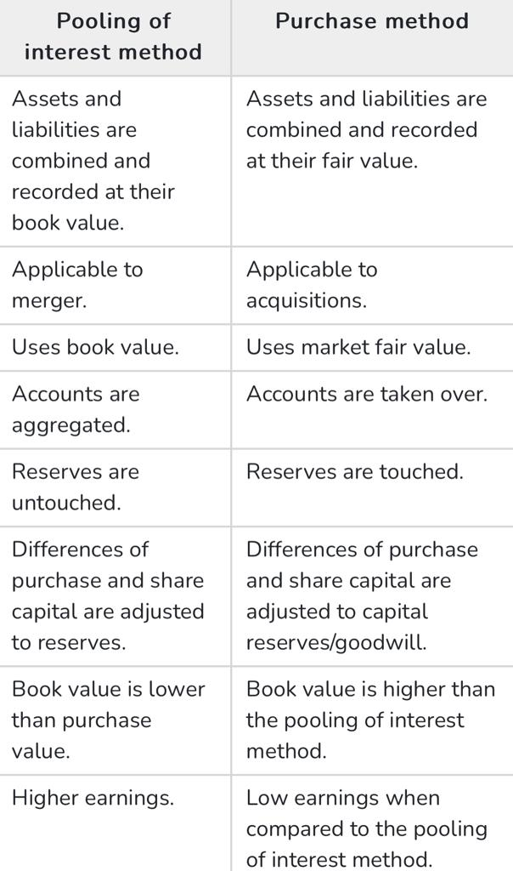

**Q13)Difference between the Purchase Consideration and Net Assets transferred**?

Any excess of the amount of purchase consideration over the value of the net assets of the transferor company acquired by the transferee company should be recognized as goodwill in the financial statement of the transferee company. Any short fall should be shown as capital reserve. Goodwill should be amortized over period of five years unless a somewhat longer period can be justified.

In simple terms, where in case of purchase method- the amount to be transferred to capital reserve or to be recorded as Goodwill- can be computed in the following 3 steps-

Step I- Find out the Net assets amount using the following formula- Total assets-

Outside liabilities (Non-current liabilities + Current Liabilities)

Step II- Compute the purchase consideration using any of the methods as given under Purchase consideration computation.

Step III- (a) If Step I- Step II= Positive amount- then it is capital reserve- since the assets received more than the amount paid as purchase consideration to acquire them.

(b) If Step I- Step II= Negative amount- then it is to be recorded as Goodwill (intangible asset) - since the amount paid for acquiring business is more than the Net assets, which is technically due to its goodwill.

**Q14) Explain the condition for amalgamation in nature of merger?**

Ans- Amalgamation in the nature of merger is an amalgamation, which satisfies all the following conditions:

(i) All the assets and liabilities of the transferor company become, after amalgamation, the assets and liabilities of the transferee company.

(ii) Shareholders holding not less than 90% of the face value of the equity shares of the transferor company (other than the equity shares already held therein, immediately before the amalgamation, by the transferee company or its subsidiaries or their nominees) become equity shareholders of the transferee company by virtue of the amalgamation.

(li) The consideration for the amalgamation receivable by those equity shareholders of the transferor company who agree to become equity shareholders of the transferee company is discharged by the transferee company wholly by the issue of equity shares in the transferee company, except that cash may be paid in respect of any fractional shares.

(iv) The business of the transferor company is intended to be carried on, after the amalgamation, by the transferee company.

(V) No adjustment is intended to be made to the book values of the assets and liabilities of the transferor company when they are incorporated in the financial statements of the transferee company except to ensure uniformity of accounting policies. For example, if transferor company is following weighted average method for inventory valuation, the book value of the inventory of the transferor company will be revised by applying the FIFO method

**Q15) Short note on purchase consideration?**

Ans- 'Accounting for Amalgamations' term purchase consideration as the "aggregate of the shares and other securities issued and the payment made in the form of cash or other assets by the transferee company to the shareholders of the transferor company"

The important point to be noted here is the amount paid towards the equity shareholders and preference shareholders is only considered as part of the purchase consideration as per the definition under AS-14. Hence, it should be noted that purchase consideration does not include the sum which the transferee company will directly pay to the debenture-holders or creditors of the transferor company. If a certain liability of the transferor company has not been taken over by the transferee company it will be discharged by the transferor company.

The purchase consideration can be computed in the following methods-

Lumpsum method- Under this method, the transferee company agrees to pay a lumpsum/fixed amount to shareholders of the transferor company.

2. Net payment method- Under this method the transferee company makes individual payments to the equity shareholders and preference shareholders either by way of cash issue or shares and debentures.

3. Intrinsic value or share exchange method - Under this method, the purchase consideration is calculated at the intrinsic value of shares of the transferor or transferee company . The ratio of shares to be issued is computed and multiplied with intrinsic value. Total share capital of the transferor company shall be divided by the total number of shares.

**Q16) Auditing?**

Ans- **Meaning and Definition-**

An audit is independent examination of financial information of any entity, whether profit oriented or not, and irrespective of its size or legal form, when such an examination is conducted with a view to expressing an opinion thereon.

This definition has the following implications:

(a) Audit is independent examination

(b) examination is of financial information when the objective is to express an opinion.

(c) requirement of audit applies in case of every entity, whether profit oriented or not, whatever is the business size of entity, whatever is the legal form of the entity.

**Features-**

1. Systematic examination- characterized as a systematic and scientific examination of the books of account of an organization.

2. Check arithmetical accuracy- checks the arithmetical accuracy of the books of account by the verification of postings, castings, balances, etc.

3. Check completeness-check that none of the entries in the books of account of the client have been omitted in the process of compilation and that nothing which is not in the books of account has found a place in the year-end statements.

4. Done by an independent person or firm-To be carried out by an independent person (or a firm) who is duly qualified for the job. Should be competent, independent, qualified, and should be possessing the prescribed qualification & certificate of practice.

5. Verification of financial results

**Benefits-**

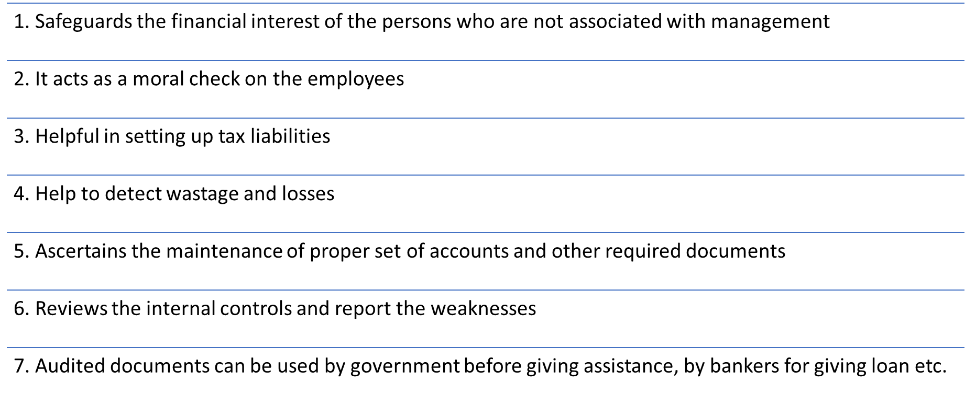

**Limitation-**

1) Judgement In Financial Reporting

2) Generalization and Estimation on the part of the auditor

3) Human Error

4) Ambiguity regarding accounting treatment of certain financial transactions

5) Sample-Based Auditing

6) Management Cooperation Dependency

**Types of Audit-**

* Statutory Audit and Internal Audit
* Internal audit is done voluntarily without any legal force, whereas Statutory audit is authorized and governed by law.
* Although certain types of companies are required to appoint an internal auditor under the Companies Act 2013, there are no reporting guidelines prescribed by the act. The company can in consultation with the Internal Auditor, formulate the scope, and methodology for conducting the internal audit.

**Q17) Difference between Internal and External Audit?**

|  |  |
| --- | --- |
| Internal Audit | External Audit |
| 1)Internal Audits A company is usually able to select its own internal audit lead and team members.  2)Members of the audit team often do not need to have specific titles or licenses.  3)Audit reports are primarily used by internal management to improve company operations.  4)Internal audits may be less formal with blurred structure as the auditor provides casual guidance. | 1)External Audits A company or board can usually pick the audit firm but not audit team members.  2)Members of the audit team may be required to hold specific titles or license as part of the audit agreement.  3)Audit reports are primarily used by external parties to satisfy a reporting requirement.  4)External audits are often more formal with defined boundaries and disallowed services. |

**Q18) Concept of Discounting of bill?**

Ans- Concept od Discounting of bill are-

Issuing the bill: A seller or creditor sells goods or provides services to a buyer or debtor on credit. Instead of waiting for the payment due date, the seller may choose to accelerate the receipt of funds by using a bill of exchange or promissory note.

Presenting the bill for discounting: The seller takes the bill to a financial institution (discounting house or bank) and requests the bank to discount the bill. The bank evaluates the creditworthiness of the debtor and the quality of the bill before deciding whether to accept it for discounting.

Calculation of the discount: The bank calculates the discount based on the face value of the bill, the remaining time until maturity, and an agreed-upon discount rate. The discount rate represents the cost or interest charged by the bank for providing funds before the bill's maturity.

Receipt of funds: The bank pays the seller the discounted amount, which is the face value of the bill minus the discount. The seller receives immediate cash or credit to their account.

Responsibility for collection: The bank assumes the responsibility of collecting the full face value of the bill from the debtor on the maturity date. The bank earns a profit by receiving the full amount of the bill from the debtor when it matures.

**Q19)Types of investment ?**

**Ans-** Held-to-Maturity, (HTM): Securities acquired by banks with the intention to hold them upto maturity should be classified as HTM.

Held-for-Trading (HFT): Securities acquired by banks with the intention to trade by taking advantage of short-term price/interest rate movements should be classified as 'held-for-trading'.

Available-for-Sale (AFS): Securities which do not fall within the above two categories should be classified as 'available-for-sale'.

The banks will have the freedom to decide on the extent of holdings under HFT and AFS. This will be decided by them after considering various aspects such as basis of intent, trading strategies, risk management capabilities, tax planning, manpower skills or capital position. The investment classified under HFT would be those from which the bank expects to make again by the movement in the interest rates/market rates. These securities are to be sold within 90 days. Profit or loss on sale of investments in both the categories will be taken to the Profit and Loss Account.